|  |  |  |  |  |
| --- | --- | --- | --- | --- |
| **TEST** | **EXPECTED** | **ACTUAL** | **P/F** | **NOTES** |
| Home page |  |  |  |  |
| Click on book an appointment | Redirects to booking page | Redirects to booking page | pass | To develop more, I would add a quick book an appointment section for users who are already logged in where the booking system would be in the home page with a much simplifer form. |
| Click on the services button | Redirects to services page | Redirects to services page | pass |  |
| Hover on cards | Expands gradually, drop shadow and buttons color change on hover | Expands gradually, drop shadow and buttons color change on hover | pass |  |
| Click on learn more buttons in cards | redirects to services and treatments page | redirects to services and treatments page | pass |  |
| Hover on articles | Expands gradually, drop shadow and buttons color change on hover | Expands gradually, drop shadow and buttons color change on hover | pass |  |
| Click on learn more buttons in article 1 (who are we) | redirects to about us page | redirects to about us page | pass |  |
| Click on learn more buttons in article 2 (what do we offer) | redirects to services and treatments page | redirects to services and treatments page | pass |  |
| Services page |  |  |  |  |
| Click on book now buttons | Redircts to log in page | Redircts to log in page | pass | For more professional, I would add make the articles clickable and when they are clicked the background would fade out and a pop up box with more description about the treatment come up |
| Log in page |  |  |  |  |
| Click on email adress field | Customer would type in their email adress | Customer would type in their email adress | pass |  |
| Click on name field | Customer would type in their name | Customer would type in their name | pass |  |
| Click on password field | Customer would type in their password | Customer would type in their password | pass |  |
| Click on log in button  commit id: c78192a | Redirects to booking page | Redirects to booking page | pass |  |
| Booking page |  |  | pass |  |
| Click on drop down menu | A list of treatments appear and customer would choose prefered treatment | A list of treatments appear and customer would choose prefered treatment | pass |  |
| Click on the date field | Customer would eithet type in the date or use the displayed calendar to choose a date | Customer would eithet type in the date or use the displayed calendar to choose a date | pass |  |
| Click on name field | Customer would type in their name | Customer would type in their name | pass |  |
| Click on email adress field | Customer would type in their email adress | Customer would type in their email adress | pass |  |
| Click on phone number field | Customer would type in their phone number | Customer would type in their phone number | pass |  |
| Click on book an appt. button  Commit id: cf7ec64 | A modal would pop up with appointment confirmation. | A modal would pop up with appointment confirmation. | pass |  |
| About us page |  |  |  | For this page I should have added a comment section where their would be clients review. |
| Hover on article 1 | Expands gradually, drop shadow. | Expands gradually, drop shadow. | pass |  |
| Hover on article 2 | Expands gradually, drop shadow and learn more button color change on hover | Expands gradually, drop shadow and learn more button color change on hover | pass |  |
| Click on learn more button | Redirects to services page | Redirects to services page | pass |  |
| Hover on cards | Expands gradually, drop shadow and buttons color change on hover | Expands gradually, drop shadow and buttons color change on hover | pass | For more professional, I would add make the cards clickable and when they are clicked the background would fade out and a pop up box with more description about the treatment come up |
| Click on the buttons in the cards | Redirects to the services page | Redirects to the services page | pass |  |
| Would like to visit us button | Redirects to booking page | Redirects to booking page | pass |  |

**Using validator to fix errors:**

Most of my errors were unclosed elements. So for this since the errors were after each others. I closed the section tag and after the closing tag added 2 divs closing tags.

the issue here was is that I had an a href inside a button element which does not work in code. I fixed it by changing from an a href inside a button to just an a href with bootstrap

classes that would match the style wanted.

Before:

After:



I had double class in the same div. so I removed the duplication and combined them together:

Before: 

After:



This image element had an unnecessary slash which could break the code. I removed the slash. Before and after:

Was getting this in most of the pages, but it meant that the body or either main element had inside of it tags that were unclosed. This would go away as I fix the code through.

For this I had a class without a div. to fix this I added the container class inside a div element:

Before: after:

For some of the pages, since the footer was copied and pasted on each, I had a missing closing tag for the footer:

Before:

After:

For this I had an issue with the id number as I wrote for the place holder phone number but then for id its just a number, here is how I fixed it:

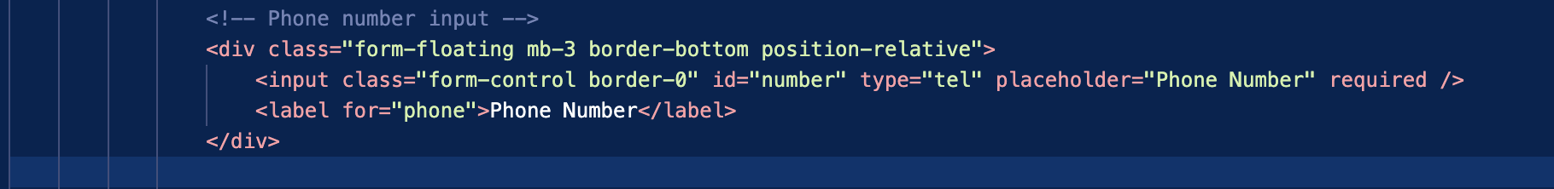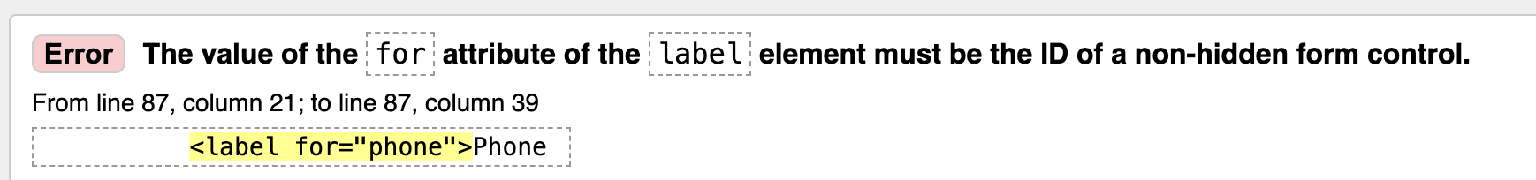

Before:

After:

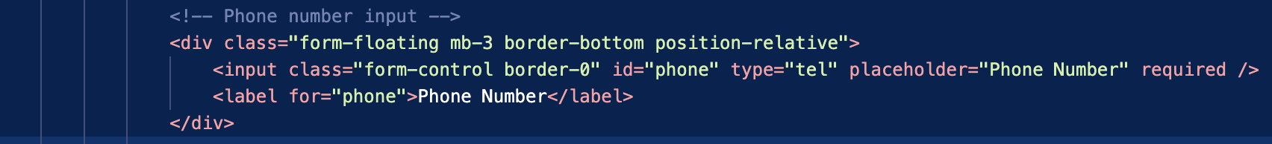

Improvement notes:

For future improvement, I would work on making the website 100& functional, such as:

When logging in u need to write an actual email address and password, and if u don’t have an account, u would need to sign up and create one

A live chat support for older age groups to help them with the website user experience

Would improve the accessibility more, such as users could choose to make the text larger for those with eyesight problems or a read out function for those with dyslexia.

A multi-language support, I would make the website translatable

A review comments section helps new customers trust the visited website and business.

An online payment method – users get to pay for their treatment online ( this could be helpful for those wanting to gift a session for someone)